 | Prerana Educational and Social Trust®  PES Institute of Technology and Management  NH-206,Sagar Road,Shivamogga-577204
Department of Computer Science and Engineering

Operating Systems Project Assignment (BCS303)
Date of Submission:

Marks Obtained: /10

Submitted By:
 | Name: | Gajanan Govind Gowda
 | USN: | 4PM24CS045
 | Semester: | 3 |  | Section | A
Signature of the Student |  |  | Submitted To,  Mr. Raghavendra K,  Assistant Professor,  Department of CSE, PESITM, Shivamogga.

Demand Paging Simulator with Page Fault Tracking
Aim / Objective:
- To simulate demand paging
- To study page replacement algorithms (FIFO, LRU, Optimal)
- To calculate page faults and page fault rate
Problem Statement:
To simulate the demand paging mechanism in an operating system where pages are loaded into main memory only when a page fault occurs, and to analyze the page fault rate for different page sizes by tracking the number of page faults generated for a given sequence of memory accesses.
Introduction:
Demand paging is a memory management technique used in operating systems in which pages are loaded into main memory only when they are required. This approach reduces memory usage and improves system efficiency. In this experiment, demand paging is simulated using FIFO, LRU, and Optimal page replacement algorithms to analyze page faults and page table behavior.
Theory:
Demand paging is a memory management technique used by operating systems in which pages are loaded into main memory only when they are needed. Unlike pre-paging, demand paging avoids loading unnecessary pages, thereby saving memory and reducing I/O overhead.
When a process accesses a page that is not currently present in main memory, a page fault occurs. The operating system then:
- Detects the page fault
- Loads the required page from secondary storage into a free frame
- Updates the page table
- Resumes the execution of the process
A page table maintains the mapping between virtual pages and physical frames and indicates whether a page is present in memory.

The page fault rate is defined as:
$$\text{Page Fault Rate}=\frac{\text{Number of Page Faults}}{\text{Total Memory References}}$$
The page size plays a crucial role in system performance. Smaller page sizes lead to more pages and potentially higher page faults, while larger page sizes reduce the number of pages but may increase internal fragmentation.
Algorithm:
- Initialize page table and memory frames
- For each memory access:
- Calculate page number using
- $\text{page number}=\frac{\text{memory address}}{\text{page size}}$
- Check if the page is present in memory
- If not present, increment page fault count and load the page
- Update page table after each access
- Calculate fault rate for different page sizes
- Plot fault rate vs page size
Implementation Explanation:
The demand paging simulator is implemented using the C programming language. The program takes a sequence of memory accesses and the number of available frames as input. A menu is provided to choose one of the page replacement algorithms: FIFO, LRU, or Optimal.
For each memory access, the memory address is converted into a page number using a fixed page size. The program checks whether the page is already present in memory. If the page is not found, a page fault occurs and the page is loaded into memory according to the selected algorithm.
In FIFO, the oldest page in memory is replaced. In LRU, the page that was least recently used is replaced. In Optimal, the page that will not be used for the longest time in the future is replaced.
After every memory access, the current frame contents are displayed to show the page table state over time. The total number of page faults and the page fault rate are calculated and displayed at the end.
This program clearly demonstrates how demand paging works and how different page replacement algorithms affect page faults.
Source code:(C Language)

#include <stdio.h>
#define MAX_MEMORY 20
#define MAX_FRAMES 5
/* Display frames */
void displayFrames(int frames[], int fram) {
for (int i = 0; i < fram; i++) {
if (frames[i] == -1)
printf("%-4s", "-");
else
printf("%-4d", frames[i]);
}
}
/* Print table header */
void printHeader() {
printf("\nMemory Access | Page | Result | Frames\n");
printf("---------------------------------------------------\n");
}
/* FIFO */
int fifo(int memo_access[], int pages[], int n, int fram) {
int frames[MAX_FRAMES], front = 0, faults = 0;
for (int i = 0; i < fram; i++) frames[i] = -1; // Initialize all frames as empty (-1)

printf("\n=== FIFO Page Replacement ===\n");
printHeader();
for (int i = 0; i < n; i++) {
int found = 0;
for (int j = 0; j < fram; j++) // Check whether the current page is already in frames
if (frames[j] == pages[i]) found = 1;
// If page not found, replace the oldest page (FIFO)
if (!found) {
frames[front] = pages[i]; // Replace page at FIFO pointer
front = (front + 1) % fram; // Move FIFO pointer circularly
faults++; // Increment page fault count
}
printf("%13d | %4d | %-6s | ", memo_access[i], pages[i], found ? "Hit" : "Fault");
displayFrames(frames, fram);
printf("\n");
}
return faults;
}
/* LRU */
int lru(int memo_access[], int pages[], int n, int fram) {
int frames[MAX_FRAMES], time[MAX_FRAMES];
int faults = 0, counter = 0;
for (int i = 0; i < fram; i++) frames[i] = time[i] = -1; // Initialize frames and time array
printf("\n=== LRU Page Replacement ===\n");
printHeader();
for (int i = 0; i < n; i++) {
int found = 0, pos = -1;
for (int j = 0; j < fram; j++) // Check if page exists and store its position
if (frames[j] == pages[i]) found = 1, pos = j;
if (found) {
time[pos] = ++counter; // Update last-used time on page hit
} else {
// Find least recently used page (minimum time value)
int lru = 0;
for (int j = 1; j < fram; j++)
if (time[j] < time[lru]) lru = j;
frames[lru] = pages[i]; // Replace least recently used page
time[lru] = ++counter;
faults++; // Page fault occurs
}
printf("%13d | %4d | %-6s | ",memo_access[i], pages[i], found ? "Hit" : "Fault");
displayFrames(frames, fram);
printf("\n");
}
return faults;
}
/* OPTIMAL */
int optimal(int memo_access[], int pages[], int n, int fram) {
int frames[MAX_FRAMES], faults = 0;
for (int i = 0; i < fram; i++) frames[i] = -1; // Initialize frames as empty
printf("\n=== OPTIMAL Page Replacement ===\n");
printHeader();
for (int i = 0; i < n; i++) {
int found = 0;
for (int j = 0; j < fram; j++) // Check if page already exists in frames
if (frames[j] == pages[i]) found = 1;
if (!found) {
int replace = 0, farthest = i + 1;
// Find page that will be used farthest in the future
for (int j = 0; j < fram; j++) {
int k;
for (k = i + 1; k < n; k++)
if (frames[j] == pages[k]) break;
// If page is never used again, replace it immediately
if (k == n) { replace = j; break;
}
if (k > farthest) farthest = k, replace = j; // Select page with farthest future use
}
frames[replace] = pages[i]; // Replace optimal page
faults++; // Page fault occurs
}
printf("%13d | %4d | %-6s | ", memo_access[i], pages[i], found ? "Hit" : "Fault");
displayFrames(frames, fram);
printf("\n");
}
return faults; // Return total page faults
}
/* Display page fault statistics */
void printStats(int faults, int totalRefs) {
printf("\nTotal Page Faults = %d", faults);
printf("\nTotal Memory References = %d", totalRefs);
printf("\nPage Fault Rate = %.2f\n",(float)faults / totalRefs);
}
/* MAIN Function */
int main() {
int memo_access[MAX_MEMORY], pages[MAX_MEMORY];
int n, fram, pageSize, choice;
char retry;
// Outer loop allows re-entering new input
do {
printf("\nEnter number of memory accesses (max:%d): ", MAX_MEMORY);
scanf("%d", &n);
printf("Enter memory access sequence:\n");
for (int i = 0; i < n; i++) scanf("%d", &memo_access[i]);
printf("Enter page size: ");
scanf("%d", &pageSize);
printf("Enter number of frames (max:%d): ", MAX_FRAMES);
scanf("%d", &fram);
for (int i = 0; i < n; i++) // Convert memory addresses into page numbers
pages[i] = memo_access[i] / pageSize;
// Inner loop for algorithm selection
do {
printf("\n1.FIFO 2.LRU 3.OPTIMAL 4.Back to input/exit\nEnter choice: ");
scanf("%d", &choice);
int faults = 0; // Stores returned page fault count
switch (choice) {
case 1: faults = fifo(memo_access, pages, n, fram); break;
case 2: faults = lru(memo_access, pages, n, fram); break;
case 3: faults = optimal(memo_access, pages, n, fram); break;
case 4:break;
default: printf("Invalid choice\n"); continue;
}
if (choice >= 1 && choice <= 3)
printStats(faults, n);
} while (choice != 4);
printf("\nRetry with new input? (y/n): ");
scanf(" %c", &retry);
} while (retry == 'y' || retry == 'Y');
printf("\nProgram terminated.\n");
return 0;
}

Output:
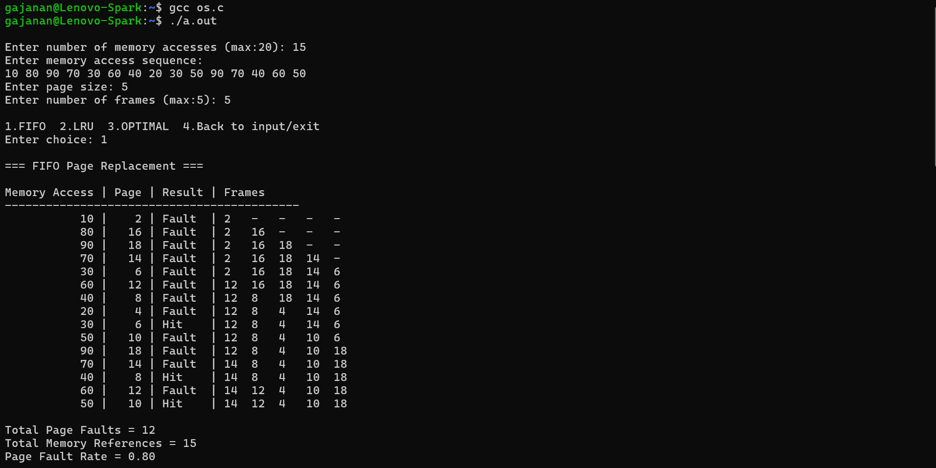
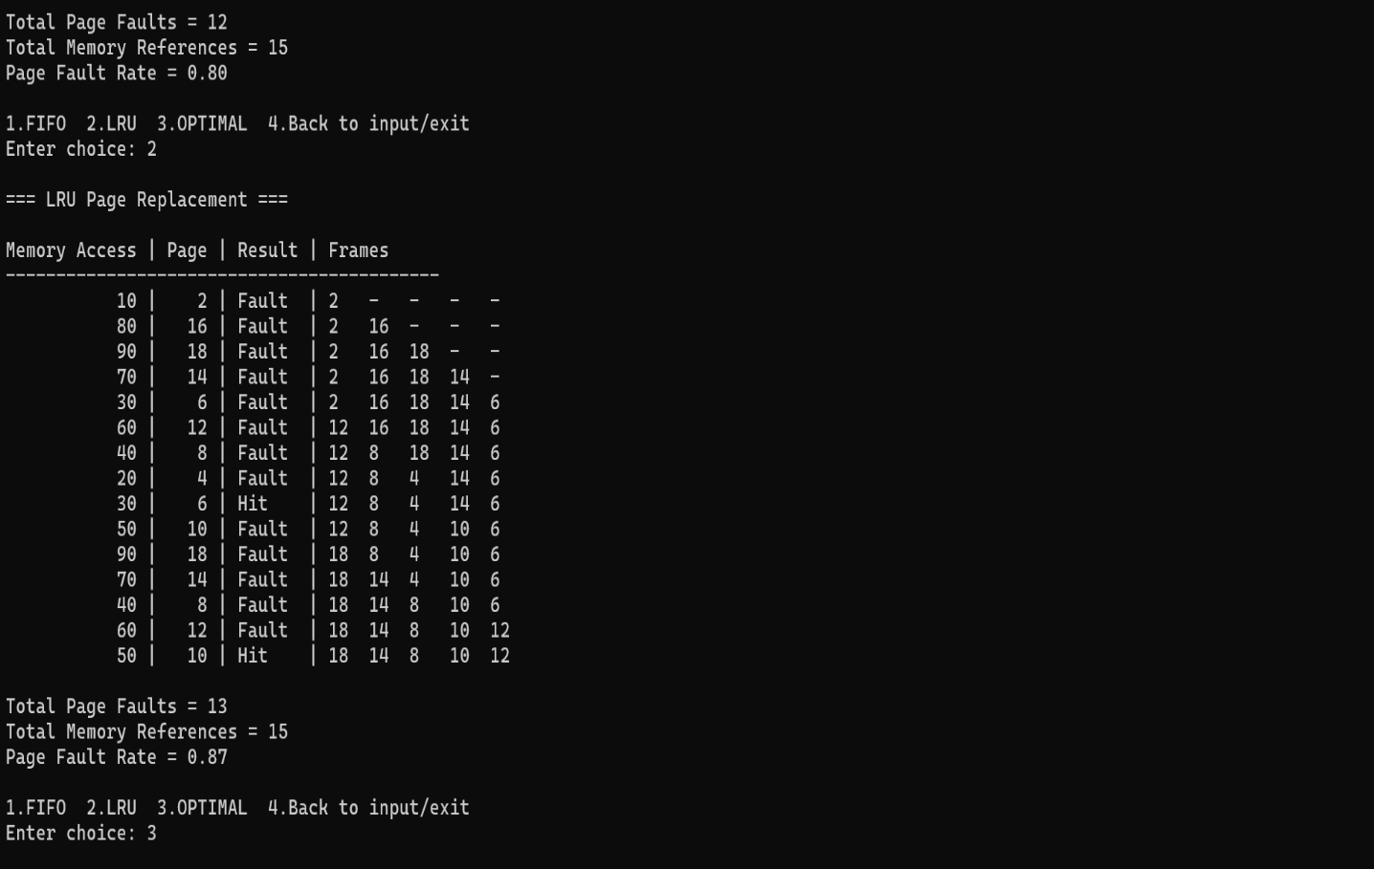

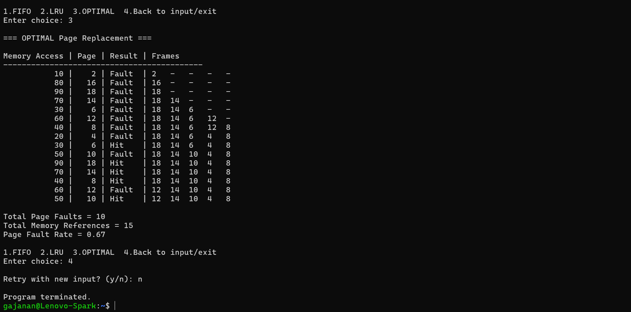
Fault rate vs. page size graph:
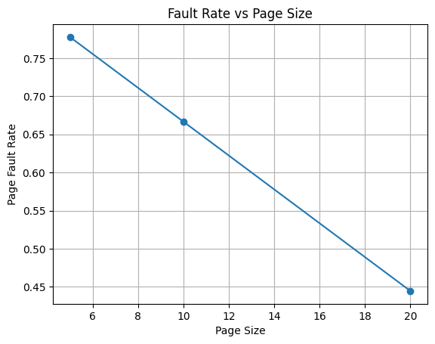

Graph Description:
- X-axis: Page Size
- Y-axis: Page Fault Rate
- The graph shows that as page size increases, page fault rate decreases.
Observation:
- Smaller page sizes result in more page faults because memory is divided into many pages.
- Larger page sizes reduce the number of pages, thereby reducing page faults.
Conclusion from Graph:
The fault rate is inversely proportional to the page size. Hence, increasing page size reduces the page fault rate in demand paging.
Conclusion:
The demand paging simulator demonstrates how pages are loaded into memory only when required. The experiment shows that increasing page size generally reduces the number of page faults. This simulation helps in understanding the importance of page size selection and the working of demand paging in operating systems.

